Python Lab Programs

1. Grade Checker Program
Program Code:
score = int(input("Enter your score: "))
if score >= 90:
print("Grade: A")
elif score >= 80:
print("Grade: B")
elif score >= 70:
print("Grade: C")
elif score >= 60:
print("Grade: D")
else:
print("Grade: F")
Sample Output:
Enter your score: 85
Grade: B
Key Functions / Keywords:
- input(): Takes input from user
- int(): Converts input into integer
- if-elif-else: Decision making statements
- print(): Displays

t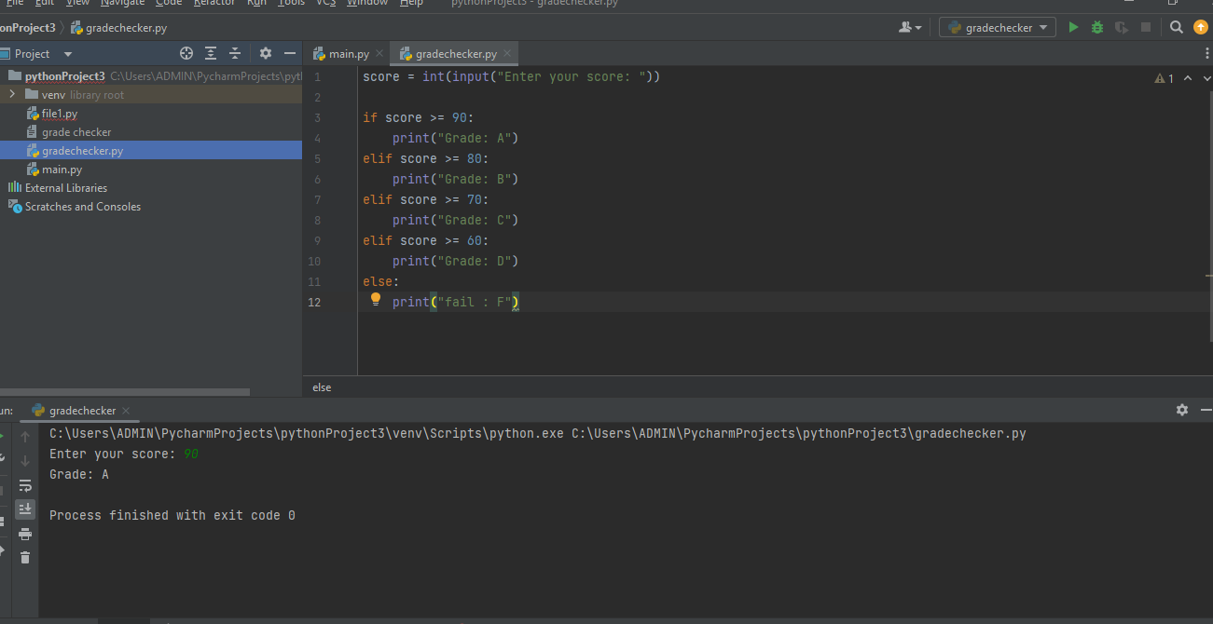

2. Student Grades Using Dictionary
Program Code:
students = {}
while True:
print("1. Add Student")
print("2. Update Student Grade")
print("3. Print All Students")
print("4. Exit")
choice = int(input("Enter your choice: "))
if choice == 1:
name = input("Enter student name: ")
grade = input("Enter grade: ")
students[name] = grade
elif choice == 2:
name = input("Enter student name to update: ")
if name in students:
students[name] = input("Enter new grade: ")
elif choice == 3:
for name, grade in students.items():
print(name, grade)
elif choice == 4:
break
Sample Output:
1. Add Student
Enter student name: Ravi
Enter grade: A
Key Functions / Keywords:
- dictionary: Stores data in key-value pairs
- while loop: Runs repeatedly
- items(): Returns key-value pairs
- break: Stops loop
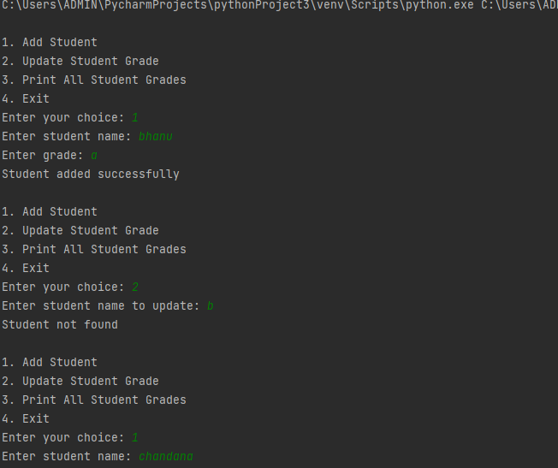
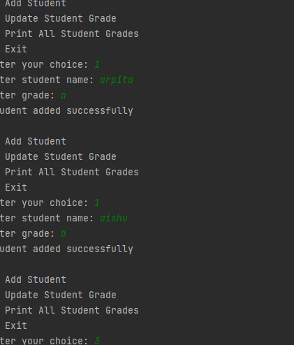
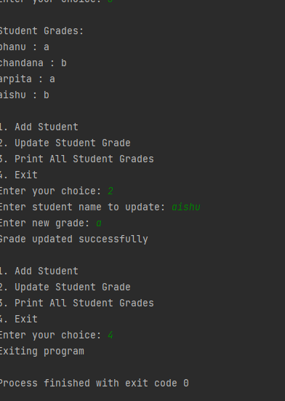

3. Write Data to a File
Program Code:
file = open("sample.txt", "w")
file.write("Hello Python File Program")
file.close()
Sample Output:
Data written successfully
Key Functions / Keywords:
- open(): Opens file
- "w": Write mode
- write(): Writes data into file
- close(): Closes file

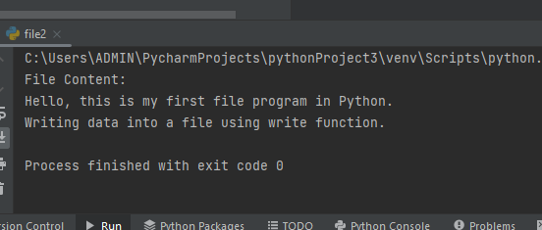

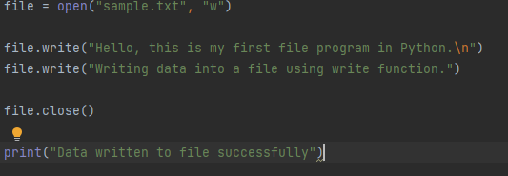

4. Read Data from a File
Program Code:
file = open("sample.txt", "r")
print(file.read())
file.close()
Sample Output:
Hello Python File Program
Key Functions / Keywords:
- "r": Read mode
- read(): Reads file content
- print(): Displays file content

